Emergency Services
Bivouac Plan
Indian Island, New York
1-3 June, 2007

Revision date: 05 May 2007

1. GENERAL

A. Type of exercise
This is primarily a Search & Rescue (SAR) training weekend. All participants will be organized using the ICS. This exercise includes small scale simulated SAR scenarios throughout the training weekend. Cadets and officers attending this event will complete the advanced training syllabus of the Ground Team Member – Level 3 (GTM3) SQTR.

B. Exercise location
The incident command post (ICP) will be located at Indian Island Campground, in Riverhead, NY. All field and classroom training will be conducted within the confines of the campground, utilizing available resources.

C. Exercise Dates & Times
Primary Mission Dates: 1-3 Jun 2007. 1700L – 1600L
Alternate Mission Dates: Weather will not cancel the exercise

D. USAF funding
No USAF funding is required or requested for this exercise.

E. Mission Symbol & Number
Local Training mission number – LIG–07–06–01

F. Staff Requirements
 | Name | Home # | Work # | Cell # | E-mail
Project Officer | Nathan Hillard | 631-286-4614 | 631-244-2483 | 631-942-9488 | nhillard@arinc.com
Incident Commander (IC) | Louis Fenech |  | 631-563-3440 | 631-398-8511 | lou@royalholiday.com
Safety Officer (MSO) | Edward Rymas | 631-736-6638 |  |  | yojimbo1518@aol.com
Asst Safety Officer | Stephan Ervin
Operations Section Chief (OSC) | Nathan Hillard | 631-286-4614 | 631-244-2483 | 631-942-9488 | nhillard@arinc.com
Medical Unit Leader | Dianne Collazo | 631-363-2855 |  |  | dmcplus2@optonline.net

2. NOTIFICATIONS AND APPLICATION
A. Qualification requirements
All attending personal must have at least General Emergency Services (GES) qualification. All personnel qualifications will be checked from MIMS on 1 June 2007.

3. EXERCISE DESCRIPTION
The primary objective of the exercise is to ground teams with a realistic environment in which to train and practice their mission specialty skills. Ground team trainee’s will be conducting ELT and missing person sorties.

A. Schedule of Events

Go / No Go Decision
A NO GO decision only (due to weather or other unforeseen circumstances) will be disseminated via email/telephone to the participants NLT 1200L 1 June 2007.

Exercise Events
1 June 2007
1600L – ICP / instructor staff arrive and stand up ICP.
1700L – Participants arrive, evening field training begins.

2 June 2007
0600L – 2200L - Field training and exercise sorties. Complete training outline follows.

3 June 2007
0600L – 1600L – Field training and exercise sorties. Complete training outline follows.
1600L – Dismissal. ICP stood down.

Training Outline

Basic First Aid Class
Basic Communications User Training
Direction Finder Orientation Class
ELT Practice Sortie
Search Line Techniques Class
Missing Person / Aircraft Search Practice Sortie
Land Navigation Class
Land Navigation Practice Session
Fire Starting / Extinguishing Class
Other Classes / Sorties that can be accomplished within scope and schedule

Post-Exercise Reports
After action report and training summary will be provided to LIG upon request.

B. Cadets
Cadet training is one of the primary reasons for this exercise. As such, they will be involved in most aspects of the exercise. This includes Ground Teams, Communications, Logistics, Planning, and Training (qualified only).

5. GROUND OPERATIONS
A. Ground operations resource requirements
Multiple Ground Teams are authorized for this exercise.

B. Ground operations execution
Ground Teams will be tasked DF on a practice beacon. They will also be used for a simulated missing person search. Possible first aid scenarios may be assigned or limited extrication techniques may be practiced.

6. COMMUNICATIONS
A. Normal Procedures

TBA

All coordinates will be in latitude / longitude.

B. Lost Comm Procedures

C. Callsigns
Incident Command Post: “Gabreski Base”
Ground Team: “Ground Team X” (X = numerical order starting with 1)
Vehicle: “Van X” (X = numerical order starting with 1)
Safety: “Safety X” (X = numerical order starting with 1)

D. Frequencies
Ground to ICP Designator: TBA
Ground to Ground (ground teams or mobile): TBA
Mission base phone number is: 631-942-9488 / 631-398-8511

7. SAFETY
Mission operations will be accomplished IAW CAPR 60-3, CAPR 62-1, and mission checklists. Ground Ops will coordinate with the Mission staff to assure that critical mission/safety information is briefed to ground teams. Risk management matrix techniques shall be used by all personnel to evaluate/control operational risks.

8. OTHER AGENCY INVOLVEMENT
No outside agencies are expected to participate.

9. LOGISTICS
A. Vehicle Support
No vehicle support is authorized for this activity.

B. Billeting
All participating members will bring their own tents / shelters.

C. Messing
All participating members will bring their own food. A dinner barbeque will be provided on Saturday night, and lunch will be served on Sunday.

D. Medical
All medical problems must be coordinated with the Medical Officer. The nearest hospital is:

Central Suffolk Hospital
1300 Roanoke Ave, Riverhead, NY 11901

Directions:

Exit the campground. Make a right onto Cross River Dr. (105). Less than a mile ahead will be Main Rd (58). Make a left onto Main Rd. The hospital will be on the right after about a mile and a half.

Attachment 1: Facility Information

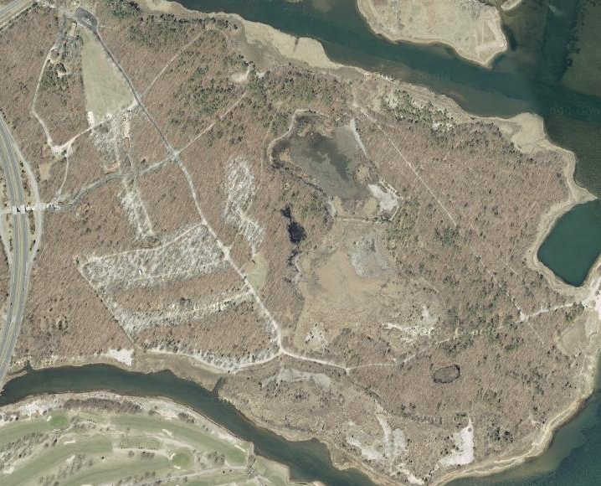

N
ICP
Practice Area #1
Practice Area #2
Restrooms
Pavilion

